Installation and configuration of Locus Map on Windows 10 pc

# Foreword

Remember that all actions you take on your own responsibility.

# Caution

Installer and app can notify you about possible performance problems about virtualization not being enabled. Follow this HowTo to solve that: <https://support.bluestacks.com/hc/en-us/articles/115003174386-How-can-I-enable-virtualization-VT-on-my-PC->

# Installation and configuration

1. Download an installer BlueStacks z <https://www.bluestacks.com/download.html> (ok. 1MB)
2. Install (around 2GB)
3. Log in with Google Play account of your choice. If you already bought Locus Map Pro and Live Tracking subscription then you can use that account.
4. Find Locus Map / Locus Map Free  
   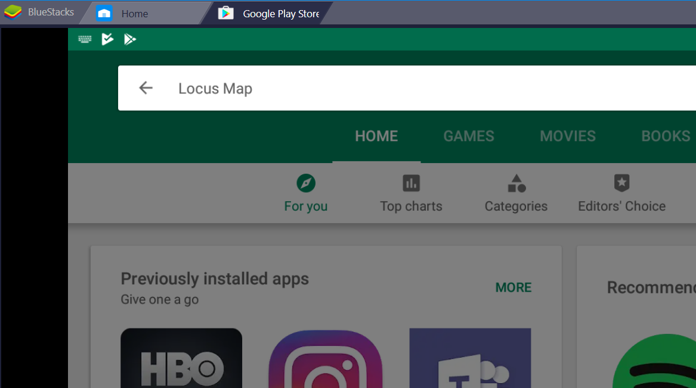
5. Install Locus Map / Locus Map Free  
   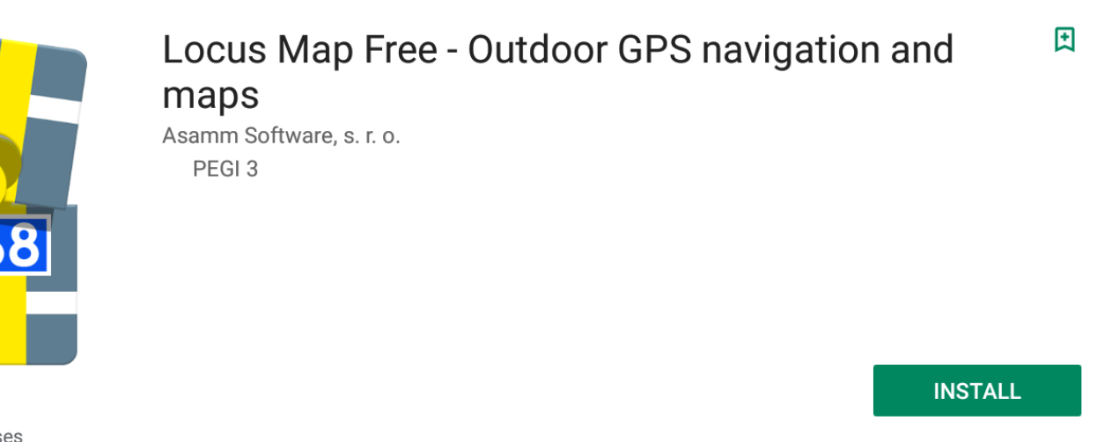  
   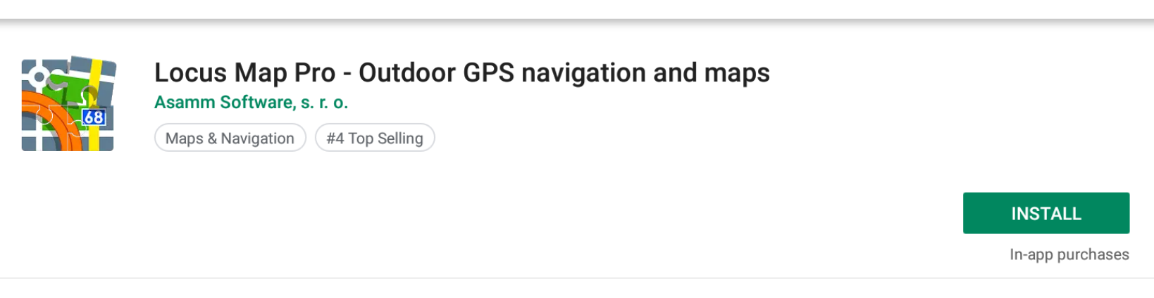
6. Run Locus Map
7. Add permissions to resources (Allow)  
   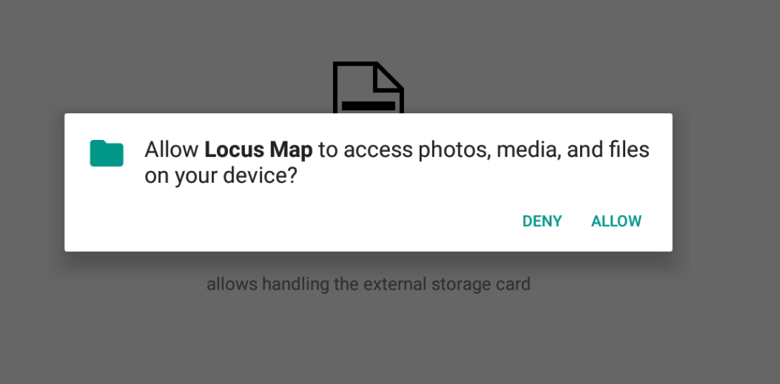
8. Add permissions ro location (Allow)  
   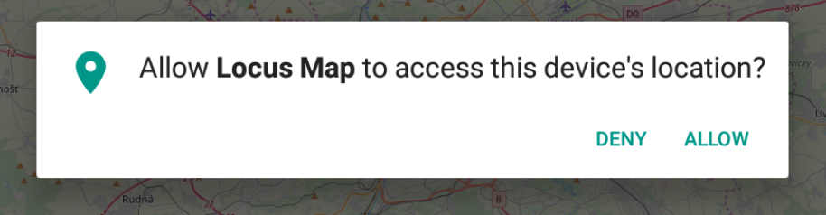
9. Correctly installed app  
   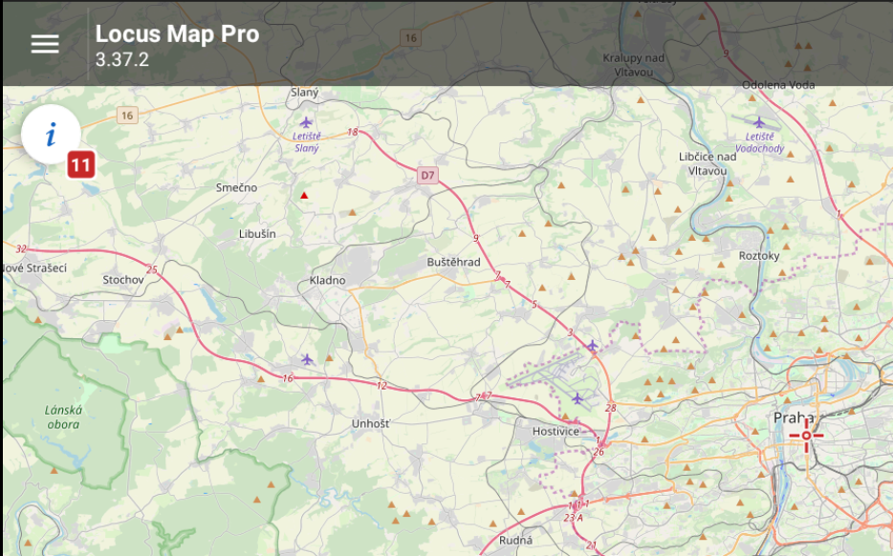
10. Click location icon in the bottom right corner  
    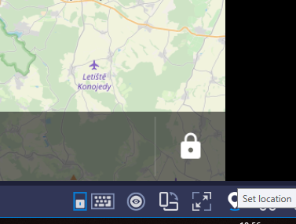
11. Enter some name of the location close to a point you want to report to Live Tracking  
    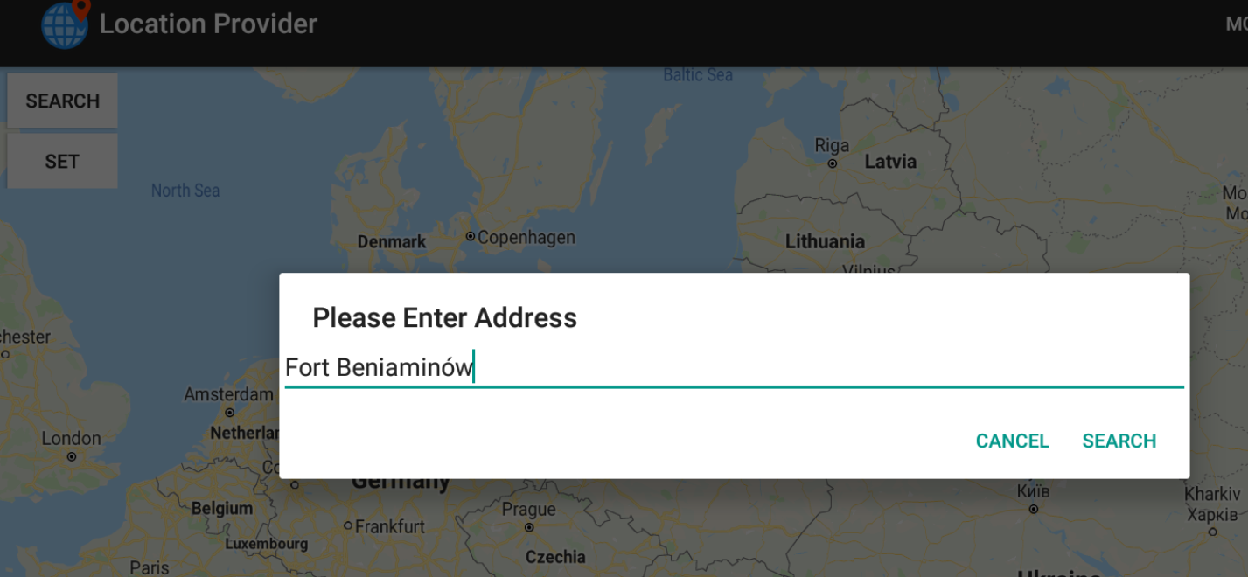
12. After clicking Search, click Poland (Might be different for you)  
    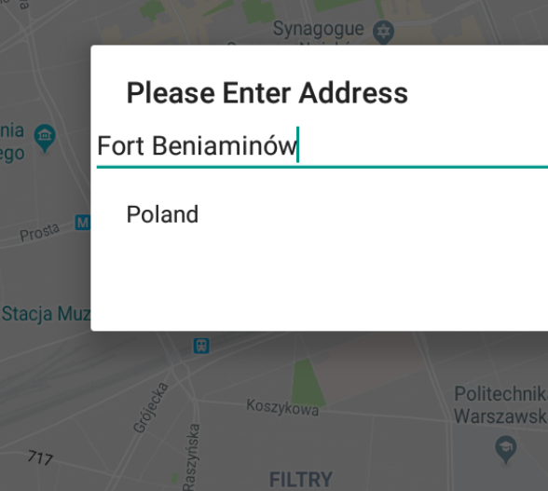
13. You will see a location  
    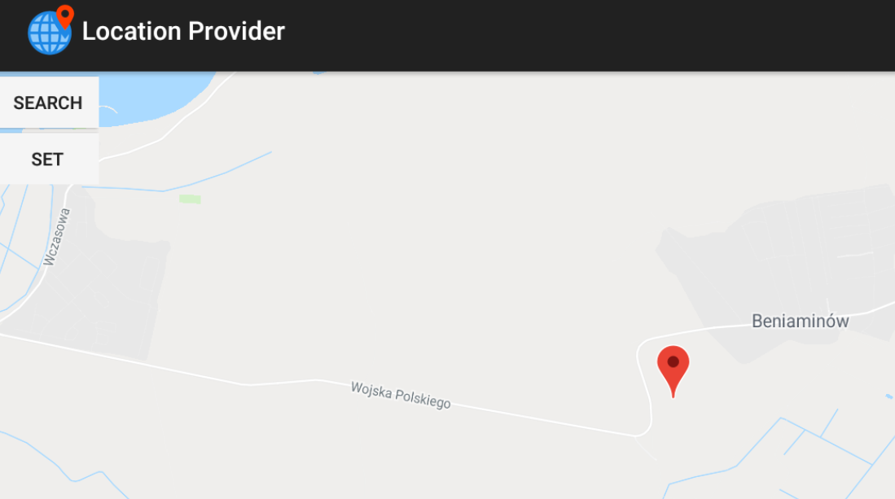
14. Klick somwhere else to report that location as yours  
    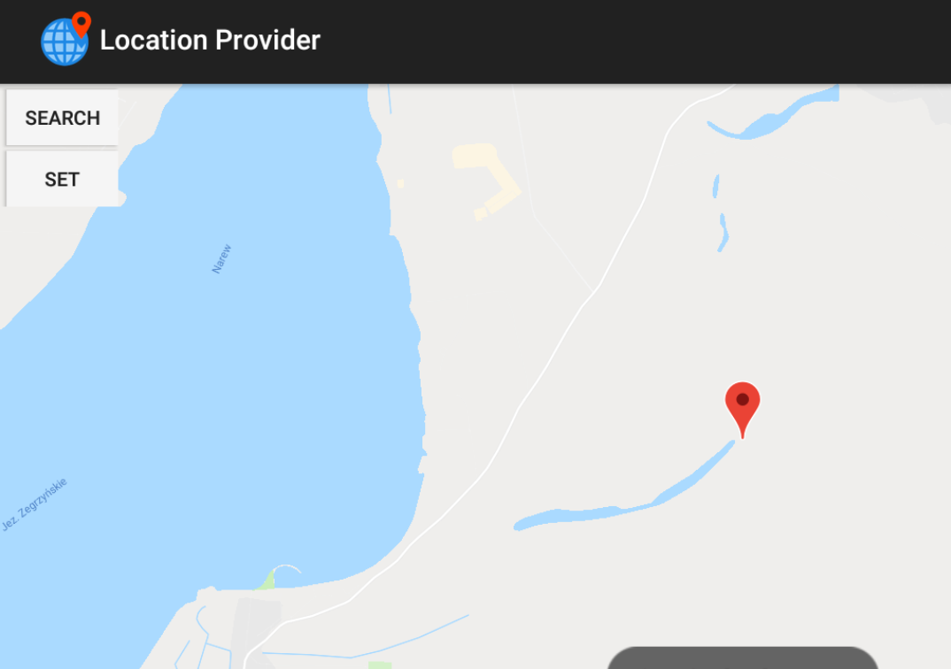
15. Click Set to remember it. Locus will now think that is what GPS shows  
    